**Term of Reference** **for Manufacturing and installation of Multi-Functional Solar Platform – MSP with capacity of (63 kWp) under " Light Up your Future’: Socio-economic Empowerment of Young Refugees in Sudan through Sustainable Energy Solutions project funded by the Islamic Development Bank.**

# INDEX

1. INDEX 1

2. List of abbreviations 2

3. Organization Background: 3

4. Project Background 3-4

5. Objective of the Task: 5

6. Technical Specifications: 6-20

7. Power demand 21

8. Operating Conditions : 22

9. Plan International Sudan Responsibilities: 23

10. Consultant Activities and Responsibilities:: 23

11. Expected Consultant Deliverables: 23

11. Consultant profile: 23

11. Submission information: 24

10. Data Confidentiality and Privacy and Safeguarding of children and young people 24

11. Terms of payment : 24

11. Annexes 25-26

# List of Abbreviations

|  |  |
| --- | --- |
| A | : Amp |
| AC | : Alternating current |
| Ah | Amp-hour |
| DC | : Direct current |
| MSP | : Multifunctional Solar platform |
| V | : Volt |
| VA | : Volt-Ampere |

# Organization Background

Plan International is an independent child rights and humanitarian organization committed to children living a life free of poverty, violence and injustice. We actively unite children, communities and other people who share our mission to make positive lasting changes in children’s and young people’s lives. We support children to gain the skills, knowledge and confidence they need to claim their rights to a fulfilling life, today and in the future. We place a specific focus on girls and women, who are most often left behind. We have been building powerful partnerships for children for more than 75 years, and are now active in more than 70 countries. In Sudan, Plan operates in four states which are White Nile, North Kordofan, Kassalla and North Darfur. The assessment is to be conducted in White Nile South Sudanese Refugees camps and host communities in Al Salam locality, with focus on Al Redis 2 camp.

# Project Background:

The current crisis in South Sudan (SSD) started in Dec. 2013 and affects the South Sudanese population. The project focus on refugees displaced to White Nile state in Sudan particularly refugees in Al Redis 2 and the host community.

The project intends to create employment and self-employment opportunities for the refugees affected by the Conflict in South Sudan and other nearby countries, by providing with capacity building trainings and the development of Income Generating Activities based on renewable Energy solutions such as a Multifunctional Platform, object of this tender, and a solar oven which will be installed by the project.

The project is designed around three Expected Results - each representing a thematic component, which complements the following:

* Component 1: Capacity Building and Skills Development
* Component 2: Renewable Energy–Based Income Generating Activities
* Component 3: Sustainability and Scale-up Facilitation

**Project Objective:** This project contributes to improving the socio-economic situation of youth (males and females) living in host communities and refugee camps in Sudan through capacity and skills development and through enhancing their access to clean, modern, reliable and sustainable energy for income-generating activities (IGAs)

* Outcome 1: Readiness of marginalized youth enhanced by improving their competencies (skills, knowledge and practices) to engage in sustainable livelihood activities in renewable energy
* Outcome 2: The economic productivity of marginalized youth improved to contribute to the economic wellbeing of themselves, families and the community
* Outcome 3: Improvements in the sustainability of new and existing renewable energy livelihoods project.

Beneficiaries: 60 youth (50% women) will benefit from training opportunities, direct employment opportunities and livelihood opportunities for self-employment and micro-businesses (Please see Annex 1 for more information).

Multi-Functional Solar Platform (MSP) is a project that presents findings and recommendations based on a labor market and energy needs assessment conducted in **ALAGAYA** refugee camp and host community, in **ALAJABALAIN** Locality, White Nile State.

The scope of the project is to cover all the existing small-scale businesses in **ALAGAYA** markets. The most dominant kinds of business activity in the two targeted markets are vegetables selling, fresh fish selling, small mobile charging, dried food making, tea making, food making and small shops.

The project intends to create employment and self-employment opportunities for the refugees affected by the Conflict in South Sudan and other nearby countries, by providing with capacity building trainings and the development of Income Generating Activities based on renewable Energy solutions such as a Multifunctional Platform, object of this tender, and a solar oven.

Selection mechanism of MSP management committee is a key factor to prevent solar system in the two targeted markets from theft and damage as well as becoming a source of inter-communal conflicts. It is therefore essential to make sure that all security procedures should be taken before the installation of solar systems as follows:

* 10 members of management committee should be selected autonomously and equally from blocks committees and community-based committees such as women, youth and market committees.
* This selection mechanism should be more sensitive to/ consistent with inter-communal arrangements as well as ethnic and tribal imbalances between Nuer and Shlluk in the refugee camp, form one hand, and between community leaders (Sultans) and other influential actors (youth) inside these committees, form the other hand.
* This management committee should include a representative member from the police station in the camp to enhance the committee members’ sensitivity to security issues related to solar energy platforms that will be installed in the camp.

**Objectives of the MSP:**

The intention is to use the MSP mainly to produce flour through milling grains and sorghum which are distributed raw by World Food Program. The flour produced will then be used for the production of bread through the activity of Solar Ovens.

In addition, the MSP will be a renewable energy generator for feeding other types of economic activities that may be developed by all community members and, consequently, to strengthen their families' economic security. Initial estimation is of a 63 kWp system that maintain power demand of 31404 W and operates for 8 hours a day.

# Objective of the Task

The main purpose of this assignment is to supply and install one Multi-Functional Solar Platform (MSP) in Alagaya refugee camp in White Nile State at Algabalin locality. This Multi Solar Platform will be used to provide a sustainable energy supply for the Revenue and Income Generating Activities that will be developed around them.

In addition, the MSP will be a renewable energy generator for feeding other types of economic activities that may be developed by all community members and, consequently, to strengthen their families' economic security. The MSP location will also serve for other purposes:

* as a training center and demonstration model of Renewable Energy-based RGAs for mentoring and replication
* showroom to sell/renting Renewable Energy kits for domestic or productive users.

This way, all the community will always have the possibility to buy one solar kit (solar home systems (SHS), lantern, etc.) to run their own business and also the non-productive users can be covered.

The detail design below is based on the information produced from a preliminary study that provided a market assessment which shows market opportunities for the Income Generating Activities, as well as an energy demand assessment based on the market findings and the beneficiary’s preferences. The estimation is of a 63 kWp system.

The services covered by these technical specifications relate to the following aspects:

* Design of the MSP and users’ connections.
* procurement of all the required materials at local and/or international level, including logistics
* Installation and commissioning
* Civil works ( power house + dedicated area (solar PV pergola and protected (with a fence) area below the pergola)) as indicated in chapter 6.3.14.
* Involvement of 10 local committee members responsible for O&M in the installations phase as training purpose. Training for the O&M aspects for a 10/15 audience.
* 1-year O&M performance period.

To this end, the tenderer will be required to produce studies and execution plans for all the buildings, infrastructure and works. In particular, he must ensure that all dimensions are such that the

List of documents to be submitted for this proposal:

* Provisional order, supply and delivery schedules of the equipment to the site. **NOTE: the maximum deadline for the commissioning of the MSP will have to be no later than 4 months from the contract signature.**
* Layout plans for all the components, including Civil works;
* Cable tray routing plans;
* The electrical diagrams of the cabinets.
* Distribution gird (if applicable)
* Users connections from the connection boxes up to the meters.
* Internal user’s connection (from the meters up to the switches, sockets, lights etc).
* Justified calculation notes leading to the choice of equipment;
* The technical data sheets specifying the exact characteristics of the equipment, including warranties and relevant information;
* Detailed description of the installation;
* Financial Offer (see layout included in Annex 6).
* Insurances

All documents will be submitted in English to Plan International for approval prior to the start of the work.

# Technical Specifications

## AREA OF APPLICATION

The present technical specifications concern the supply and installation of multifunctional solar platforms (MSPs) to deliver a continuous and reliable service in the project's target camp.

These specifications are minimum requirements that must be met by tenderers. However, bidders are encouraged to propose improvements in line with the following basic principles:

(i) reliability of the equipment,

(ii) optimization of the operating and maintenance conditions to take account of climatic conditions.

(iii) ‘’Cost effective’’ technical solutions

The technical solution chosen for this project is a Micro-grid solar system, so a PV generator with a LV mini-grid supplying electricity to the various production units.

## GENERAL INSTALLATION SPECIFICATIONS

The installation of materials and equipment must be carried out according to the rules of the trade, in accordance with the standards in force:

* Materials and equipment against possible deterioration due to external causes such as storms (wind, rain), water damage, lightning etc. ;
* Against any possible wrong operation by the user or against any unexpected malfunction that could lead to premature and/or irreversible deterioration;
* Users against the risk of electric shock or other accidental hazards, in particular from the battery or the inverter;
* Buildings against any risk of accidental fire due to malfunctions or protection of the installation.

**In addition:**

The tenderer should indicate the manufacturer's warranty as specified in this document, on the various main components as well as the local or regional representation available for service and support.

* The tenderer must ensure a team of qualified technicians and workers to carry out the required tasks successfully.
* Plan International- Sudan will not allow any replacement of personnel whose qualifications have been reviewed and accepted during the bid evaluation. If replacement of such personnel is unavoidable, their replacement shall be subject to the approval of Plan International- Sudan.
* The tenderer must visit the selected sites to inspect them before installation and prepare an installation plan.
* As soon as the bidder receives the instructions to undertake the work, he must obtain written and signed approval from Plan International- Sudan on all purchased materials (PV modules, inverters, accessories and others) to be used during the installation and must obtain prior approval from the employer on the installation plan.
* The components delivered to the selected site will be taken care of by the tenderer until the final platforms are handed over to the employer. It should be noted that road conditions may be unfavourable and therefore the packaging must protect the equipment from moisture and vibration. In addition, the bidder will be responsible for the components and equipment until the end of the first year of operation and maintenance. This means that the tenderer is responsible for all components during transportation, storage, transport to sites, installation and operation during the first year (performance period). It is required to present an insurance covering the 110% of the value of the materials to be installed for the transportation, storage, installation and performance period, covering damages, losses, theft, meteorological events, during transportation, storage, installation and O&M period.
* The tenderer participating in the work is required to take out a "Civil Liability Insurance" policy to cover the financial consequences of damage of any kind caused to third parties:

1. By its staff working on the site,
2. By the equipment used on the site for which they are responsible
3. Because of the work it carried out before final acceptance.

* It is also the responsibility of the tenderer to be insured against the risk of theft, damage from any cause (e.g. transportation/logistic, meteorological events, etc) whatsoever or misappropriation of materials or prefabricated elements supplied to the site on the site.
* The tenderer shall dispose of the waste from the works undertaken, including waste and dirt resulting from the works, in accordance with the employer's recommendations for disposal. Sites shall be returned to their original state of cleanliness. If, during installation, there are old batteries that are not working, the tenderer shall, after approval by the owner, remove them and dispose of them through proper recycling channels approved by the employer.
* The tenderer must carry out a verification test for the platform.

A list of commissioning tests will be proposed by the bidder:

The tenderer, at his own cost, shall immediately repair any malfunction resulting from the test and repeat the test.

## Technical Specifications:

For bidders and suppliers, based on the site surveys to **ALAGAYA** refugee camp and the electricity power demand requirements; hereby the detailed technical specifications needed for operating **ALAGAYA** refugee camp’s market and training center with Solar Energy for **8 hours** during daytime and **solar lighting system** for the nights.

* The required solar panels are **450W** (**140 units**) for the off-grid system (63 kWp capacity).
* Off- grid inverter (**36 kW**) **three phase inverter**.
* Required backup batteries are **32 units** either **Lead Acid** or **AGM**, **48 V- 200A**, (C10).
* All the components of the solar system should be attached by certified datasheets.
* Panels will be mounted at the roof top of the training center area (**304 m2**) with height of at least **3 m** from the ground surface.

AC Loadx

Grid

AC Junction Boxx

AC Coupling Panel

DG

Battery inverters

DC junction Battery Box

Data Logging and Monitoring System

PV Modulesx

Storage Battery Rack

* + 1. **Solar Photovoltaic System Specifications**
* A solar photovoltaic system of 140 PV panels with capacity of 450 W Mono/Poly -Crystalline.
* Conformity with CE and IEC 61215, IEC 61730, IEC 61701 or any equivalent standards.
* The PV module should be capable to perform satisfactorily in temperature between +25 ο C to +60 ο C.
* Conversion efficiency should not be less than 17.3 % under STC.
* The generated DC voltage should not be less than 600 VDC.
* The module should be provided with a combiner box with IP67.
* For any supplied module, the rated output power should have tolerance in between 0-5 W.
* The PV module warranty should be at least 20 years.
  + 1. **Hybrid Inverter**
* Three-phase hybrid inverter of 36 kW, 230-400 V, 50 Hz, pure sine wave, maximum power point tracking (MPPT) inverter.
* Inverters with transformers are needed.
* The device should be integrated with LED indicators and LCD display.
* Total Harmonic Distortion (THD) should be less than 3%.
* Multistring capabilities depending on the PV array size.
* Operating temperature between +25 ο C to +60 ο C.
* Protection IP 54 as per IEC 60529.
* Maximum efficiency should not be less than 92 % at full load.
* Should be certified to meet CE and UL marking and complaint with IEC 62109.
* Should allow internet connection for remote monitoring.
* Inverter should be installed in a secured, well-ventilated powerhouse.
* Product warranty should be 5 years.
  + 1. **Mounting Structure**
* PV panels mounting structure should be fitted to the south with angle of 20ᵒ/ -90.
* The tilt angle of the structure could be changed according to different installation positions (from degrees 20 to 40 degrees).
* Easy to handle and install.
* Steel structure should be mounted with the height of 3m from the ground surface (at the highest side), with the previously mentioned single slope, fitted to the south, as in the warehouse steel structure on an area of 304 m2.
* A steel fence should cover around the area with height of 2.5 m according to children’s safety policies.
* The fence should be made of meshed wire as used in the poultry houses with thickness of 5 mm, fixed on iron props with thickness of 2 inch.
* The steel structure poles should be properly fixed with underground concrete foundation with the dimensions 50x50 cm.
* The training center’s floor should be covered with white concrete layer with the thickness of 10 cm.
* The roof should be made of metal sheets (zinc) with thickness of 35 mm.
* Anti-Corrosive property against harsh environment.
* The mounting rails, end clamp and middle clamp are made of 6000 series.
* Withstand minimum wind speeds of 140 km/Hr.

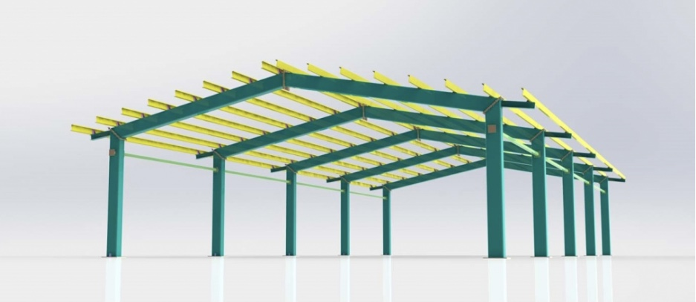

* + 1. **Solar Battery Bank & Battery Rack**
* Battery bank of 32 batteries with built in battery rack.
* Bank voltage according to inverter specifications @C10.
* Solar batteries should be lead acid or AGM.
* Stable performance at high operating temperatures of up to 55° C.
* Battery cyclic life should be at least 2500 cycles at 60% depth of discharge.
* Battery should be installed in a secured, well-ventilated powerhouse.
* The operating temperature for the battery should be +20°C to +55 °C.
* One brand of battery should be used for the entire installation.
* Wires connected to batteries should utilize appropriately sized and rated lugs or terminals and proper hardware.
* Batteries warranty should be at least 2 years with warranty certificates provided by the manufacturer.
* Battery Rack with built in busbars, powder coated with a corrosion resistant acid proof powder.
* Batteries should be tested in accordance with IEC 61427 standard.
  + 1. **Data Logging and Monitoring System**
* The main function of such system is to monitor and record energy (DC & AC part) data and system parameters on a predetermined interval basis.
* Monitoring and recording data on a pre- determined interval basis as per technical specifications should provide necessary hardware and software to measure and/or record energy parameters such as output voltage, consumed current, output frequency, power and energy.
* Could be either built in or external device.
* The system should be capable to operate through GSM/ App, should be provide all accessories needed such as SIM-card, modules, ether-net and USB
* Should provide required interface to the plant to access such data.
* System voltage 230 V / 50 Hz.
  + 1. **DC Cabling**
* Conductor: Soft annealed tin-coated flexible stranded copper per ASTM B-33 and EN 60228, TUV certified.
* Insulation: Halogen-free, thermoset polyolefin specifically designed for maximum flexibility, and Jacket (Black/Red), low

smoke non-halogenated, flame retardant, oil, abrasion, chemical and sunlight resistant cross-linked compound meeting UL 44, UL 854.

* Cable ends connections are to be made through suitable lugs or terminals, crimped properly & with use of cable glands.
* Cables between PV strings and Dc junction box should be of at least 6 mm and between Dc junction box and inverters of at least 16 mm according to inverters specifications.
* All cables should be marked properly according to approved design to be traced easily.
* PV array to battery circuit(s) should be sized for maximum 3% voltage drop at rated array power (Imp).
* Cable end connections should be made of suitable lugs, crimped with cable glands.
* Cable trays perforated type Galvanized steel cable trays, cable tray covers, clamping bolts and other cable tray accessories such as coupler plates, bends, tees, reducers, vertical elbows in manufactured accordance with ASTM A653 SS, Grade 33, coating designation G90.
  + 1. **AC Cabling**
* AC Cabling Stranded type, TUV certified, double insulation material 1kV PVC insulated cables with copper conductor.
* All cabling above ground should be suitably mounted inside PVC trunks/ cable trays with proper covers.
* Low voltage power cable with the diameter of 85mm not less than 90 m length.
* Conductor Material: Copper.
* Conductor: Class 5 flexible copper conductors BS EN 60228 2005 (previously BS6360) or equivalent international Standard.
* Insulation: PVC (Polyvinyl Chloride) to BS7655 or equivalent international Standard.
* Color: Black or White.
* Minimum Bending Radius: 6 x overall diameter.
* Nominal Voltage: 300/300-500 V.
* Temperature: -5 deg. cent + 60 deg. cent.
* Cable ends connections are to be made through suitable lugs or terminals, crimped properly & with use of cable glands.
* All cables should be correctly sized and marked properly according to approved design so that cable can be easily traced and identified.
  + 1. **AC & DC Junction Boxes**
* Two separate combining boxes (Junction boxes) AC & DC.
* The junction box should be made of metal and or tough PVC suitable for outdoor installation and has a built in SPD (Surge Protective Device) with IP 67.
* Dc junction box should include suitable Dc breakers for each string.
* Internal connection should be through busbars.
  + 1. **AC Coupling Panel**
* Should be of Metal Enclosure, Indoor, Built in SPD, RCCB, MCCB - single phase and three phase.
* Internal connection should be through busbars.
* Ingress protection must be at least IP41.
* Enclosure material should be galvanized steel sheets.
* Fault level for the main breaker: at least 25 kA.
* Advised to use high quality breakers.
* Warranty: at least 2 years.
  + 1. **Earthing System**
* Earthing System as per technical specifications including cabling, cable lugs, earthing rods and all required accessories.
* Each array structure of the PV modules should be grounded property.
* All metal casing/shielding of the system and its components should be thoroughly grounded.
* Earthing pit.
* The earth resistance should not be more than 5 Ohm.
* Earthing installation in accordance with the IEE Wiring regulations, BS 7671.
* All conductive materials should be copper.
* The size of conductor should be according to table 54.7 of IEE # BS 7671 # IEC 60365-5-54.
  + 1. **Safety aspects**

**Protection against electric shock:**

Protection against electric shock in the DC side shall be achieved by best practice and international standards and by components and systems classified as Class II or better.

For the AC side, double or reinforced insulation protection between any live conductor and any *earthed or exposed conductive part is required.

Please consider also the specifications included in the chapter 6.2.8, 6.2.9 and 6.2.10.

**Overcurrent protection:**

The inverter cable overcurrent protection should be installed between the battery and the inverter as close as possible to the battery.

In the PV generator, overcurrent protection is required in the strings: fault currents due to short circuits in the modules, in the junction boxes or in the module wiring or to ground can cause an overcurrent in a PV generator. PV modules are limited sources of current, but they can be subject to overcurrent caused either by multiple parallel adjacent strings or by external sources or both. For this reason, current protection of each string is mandatory.

Please consider also the specifications included in the chapter 6.2.8, 6.2.9 and 6.2.10.

**Protection against the effects of lightning and transient overvoltage**

The level of protection of electrical installations is important for reasons of safety of man, plant and equipment. The level of protection of electrical installations depends on many aspects such as the type of installation (overhead/underground) of the network, etc. The most important factors are described below:

* Electrical insulation material of the equipment.
* Characteristics of overvoltage protection devices.
* Appropriate earthing system.
* Lightening protection system including cables, mast and all required accessories.
* Lighting arrester should be of pure copper.
* All metal casing/shielding of the system and its components should be thoroughly grounded.

The overvoltage protection devices installed in the installation must comply with the international standard IEC 61643-11.

**Signalling**

At least the electrical diagram of the installation and the layout diagram of the photovoltaic generator components, in the form of laminated documents, will be placed near the main switchboard.

* + 1. **Main Distribution Board and Manual Change Over**

AC distribution board unit with the following specifications:

* Wall mounted Fix on Rail Enclosure.
* Protection Degree IP 55, Adjustable DIN-rails complete with earth bar.
* 36 Way Fix on Rail Enclosure.
* Main Breaker 40 A 3P MCB, C Curve, & RCCB same current rating.
* Outgoings: 10 Amps 1 P MCB, 10 No. & 16 Amps 1P MCB, C Curve Qty 25 No.
  + 1. **Solar Lighting Modules**
* Qty. of 30 isolated solar lighting modules of 500 W should power ON automatically when sunset.
* IP 66.
* Aluminum alloy body.
* Waterproof with high quality.
* Build in Lithium batteries.
* Capable of operating for at least 8 Hrs.
* Wireless remote control unit.
  + 1. **Civil works**

**Power Room**

* A power room with dimensions of 4m x 4m x 3m should be built for mounting the inverters, batteries, Ac & Dc junction boxes, data logging,etc.
* The power room should be well secured and ventilated.
* The walls should be built of red bricks (1.5 bricks) and cement mortar 1: 6.
* The roof of the power room should be of metal sheet (zinc) with the thickness of 35mm.
* The floor should be made of white concrete layer with the thickness of 10 cm.
* A wooden sheet should be fixed inside the power room for mounting the inverters, data logging,etc.
* The door should be steel (1.2 x 2.2 m) of heavy pipes (Akumi).
* 2 Steel windows covered with net mesh the dimensions of 1x 1.2m to maintain well ventilation to the power room.
* The power room should be luminous by 4 bulb lamps of 15W maximum and a ceiling fan.

**Dedicated area**

* A protected area under the solar PV generator, will be created through a fence who will delimitate the space under the PV mounting structure (pergola). This space, well prepared, will be used as training center and/or show room.
  + 1. **LV GRID and users connections**
* Low voltage power cable (as mentioned above) of a diameter of 85 mm/ 4 pole and length of at least 90 m.
* An Ac distribution fuse box (with single and three phase breakers as mentioned above) should be mounted on the power room so as to distribute the inverter’s output to the consumers.
* An Ac distribution board should be mounted at distance of 70 m (reaches the center of the market) to enable direct connections to the consumers.
* The distribution board (at the center of the market) should be mounted on a well secured position away from the reach of humans, to prevent from electrical shock or danger.
* Consumers’ connections to the load should be supplied according to the individual needs (single or three phase connections) with diameters of 2.5 mm, 4 mm and 6 mm.
* Power and energy meter must be included in the offer with a particular attention to the meter itself consumption.
* A basic set of materials for 8 – 10 users internal installation (2switches, 2 lighting points, 2 socket, installation auxiliary materials). Security conception is a project must.

|  |  |  |  |
| --- | --- | --- | --- |
| **Multifunctional Solar Platform (MSP) + Battery (operating hours: 8 am to 8 pm)** | | | |
| Business activity | Power demand (W) | Solar system sizing (W) | Battery capacity (Wh) |
| Mobile charging | 750 | 1,350 | 3,000 |
| Vegetable selling | 18 | 32 | 72 |
| Small shop | 518 | 932 | 2,072 |
| TV club | 450 | 810 | 1,800 |
| Mobile phone workshop | 2,138 | 3,848 | 8,552 |
| Total |  | 6,973 | 15,496 |
| **Solar system (operating hours: 8 am to 4 pm)** | | | |
| Mill | 13,458 | 17,495 |  |
| Welding shop | 10,036 | 13,047 |  |
| Total | 27,530 | 35,789 |  |
| **Solar refrigerator (operating hours: 24 hours)** | | | |

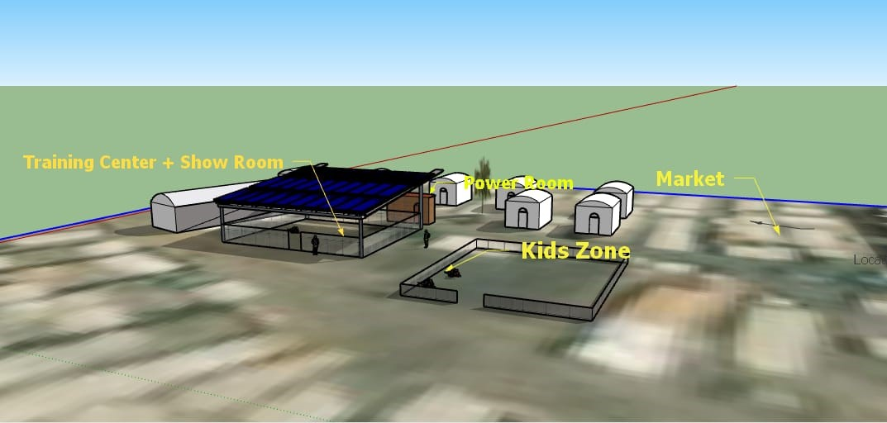

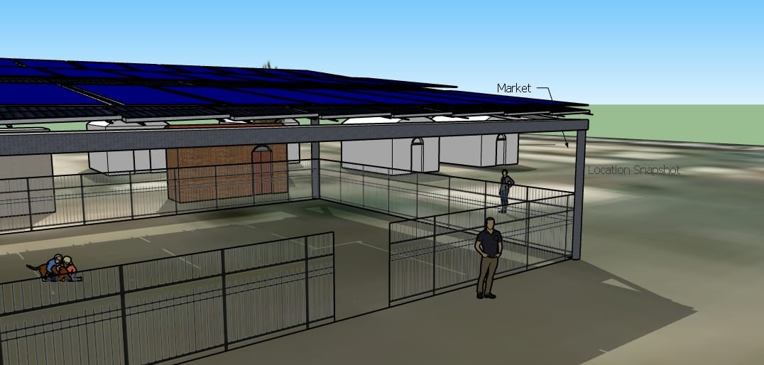



* + 1. **Metering System**
* Electrical power/energy consumption metering system should be provided for each consumer to manage the consumption.
  + 1. **System Training**

A training session should be held to technicians on systems maintenance and operation.

## Components of the MSP:

|  |  |  |  |  |
| --- | --- | --- | --- | --- |
| ITEM | REFERENCE CHARACTERISTICS | | BIDDER PROPOSED CHAARACTERISTICS | |
| **PHOTOVOLTAIC MODULES** | | | | |
| **PV generator capacity (STC)** | At least 63 kWp | |  | |
| **Mark, Model and origin** |  | |  | |
| **PV module type / STC capacity** | Mono or Poly crystalline/450Wp | |  | |
| **Voc and Isc of the module** | 49.70 V/ | |  | |
| **STEEL STRUCTURE FOR SOLAR PANELS** | | | | |
| **Type of structure** | Shed in the form of a one slope roof | |  | |
| **Mark, Model and origin** |  | |  | |
| **Tilt** | 15 to 20° south | |  | |
| **Height lowest point** | At least 3 m | |  | |
| **Wind resistance** | 140 km/h | |  | |
| **Description of the materials and of the general solution** |  | |  | |
| **THREE PHASE HYBRID INVERTER** | | | | |
| **Mark, Model and origin** | 3 phase hybrid inverter of 36 kW | |  | |
| **System voltage** | 48 V | |  | |
| **Continuous power** | 36 kW | |  | |
| **Power 5sec** | 40 kW | |  | |
| **Maximum efficiency (euro)** | >93 % | |  | |
| **Minimum MPPT input voltage** | 200 V | |  | |
| **Maximum MPPT input voltage** | 1000 V | |  | |
| **Degree of protection** | IP 65 | |  | |
| **Dimensions** |  | |  | |
| **Weight** |  | |  | |
| **Output voltage** | 220 V AC -400 V AC | |  | |
| **Network frequency** | 50/60 Hz | |  | |
| **Number of inverter units** | 1up to 4 | |  | |
| **Total rated power** | 36 kW | |  | |
| **BATTERY AND BATTERY RACK** | | | | |
| **Type/Technology** | Lead acid or AGM | |  | |
| **Mark, Model and origin** |  | |  | |
| **Voltage** | 12V | |  | |
| **Capacity at C10** | 200 Ah | |  | |
| **Number of elements** | 32 | |  | |
| **DATA LOGGING AND MONITORING SYSTEM** | | | | |
| Mark, Model and origin | | As mentioned on technical specifications. | |  |
| Modem type | |  | |  |
|  | |  | |  |
| **AC COUPLING PANEL** | | | | |
| Mark, Model and origin | | As mentioned on technical specifications. | |  |
| Disconnector | |  | |  |
| Isolating Switch | |  | |  |
| Lighning protections | |  | |  |
| IP | |  | |  |
| **AC AND DC CABLING** | | | | |
| Please indicate relevant component here (consider specs In chapter 6.3) | |  | |  |
| **PV-DC JUNCTION BOX** | | | | |
| Please indicate relevant component here (consider specs In chapter 6.3) | |  | |  |
| **EARTHING SYSTEM** | | | | |
| Please indicate relevant component here (consider specs In chapter 6.3) | |  | |  |
| **LIGHTNING SYSTEM** | | | | |
| Please indicate relevant component here (consider specs In chapter 6.3) | |  | |  |
| **MAIN DISTRIBUTION BOARD AND MANUAL CHANGE OVER** | | | | |
| Please indicate relevant component here (consider specs In chapter 6.3) | |  | |  |
| **SOLAR LIGHTING MODULES** | | | | |
| Please indicate relevant component here (consider specs In chapter 6.3) | |  | |  |
| **POWER ROOM** | | | | |
| Please indicate relevant component here (consider specs In chapter 6.3) | |  | |  |
| **SYSTEM TRAINING** | | | | |
| Please indicate relevant component here (consider specs In chapter 6.3) | |  | |  |
| **METERING SYSTEM** | | | | |
| Users meters (number, types, model, data info) | |  | |  |
| **LV GRID and users connections** | | | | |
| LV poles | |  | |  |
| Cable 85 mm (main lines; distance, type, etc) | |  | |  |
| Junction boxes | |  | |  |
| Cables (Users connections) | |  | |  |
| Users connection boxes | |  | |  |
| Internal users connections (switches, sockets, bulbs, etc) | |  | |  |
| Users meters ( type , model, etc) | |  | |  |
| SPARE PARTS | | | | |
| **Photovoltaic Modules** | |  | |  |
| **Battery Bank** | |  | |  |
| **Power Meters** | |  | |  |
| **Others** | |  | |  |

## Power demand:

The table below shows the detailed power demand and the operating hours;

|  |  |  |
| --- | --- | --- |
| **Activity** | **Power Demand (W)** | **Operating Hours** |
| Food Selling | 18 | 8:00 am- 8:00 pm |
| Flour Milling | 13,458 | 8:00 am- 4:00 pm |
| Mobile Charging | 750 | 8:00 am- 8:00 pm |
| Welding Shop | 10,036 | 8:00 am- 4:00 pm |
| TV Club | 450 | 8:00 am- 8:00 pm |
| Bakery | 4,036 | 8:00 am- 4:00 pm |
| Mobile Phone Workshops | 2,138 | 8:00 am- 8:00 pm |
| Small Shops | 518 | 8:00 am- 8:00 pm |
| Total | 31,404 |  |

The MSP location will also serve for other purposes:

1. A training center and demonstration model of Renewable Energy-based RGAs for mentoring and replication.
2. A showroom to sell/renting Renewable Energy kits for domestic or productive users.

This way, all the community will always have the possibility to buy one solar kit (solar home systems (SHS), lantern, etc.) to run their own business and also the non-productive users can be covered.

The system concepts will have to consider the following:

1. Power capacity adapted to the demand of:

* The milling infrastructure.
* Other Income Generating Activities that previously mentioned.

1. The design also considered providing space for a training center and demonstration model of Renewable Energy-based RGAs for mentoring and replication and a showroom to sell/renting Renewable Energy kits for domestic or productive users.
2. The technical specifications will allow the supply and installation of MSP in order to deliver a continuous and reliable service in the locality targeted by the project, and will consider the following basic principles: (i) reliability of equipment, (ii) optimization of operating and maintenance conditions to take climatic conditions into account.
3. The design has considered an installation in an isolated place with few qualified personnel in the mechanical and electrical fields. Resistant material is therefore required, both for the main components and for the mounting accessories, in order to require the lowest possible maintenance and to resist corrosion and long-term degradation.
4. It’s strongly recommended for the applicants to visit the site and its surroundings and to obtain by them-selves all the information which may be necessary for the proper installation.

## OPERATING CONDITIONS

The equipment requested is intended to be installed in isolated locations with few qualified mechanical and electrical personnel. Resistant material, which respects the technical specifications indicated in **Annex 1-Appendix 5**, is therefore required, both for the main components and for the mounting accessories, in order to require the lowest possible maintenance and to resist corrosion and long-term degradation.

## REFERENCE CLIMATIC CONDITIONS

In order to facilitate the comparison of tenderers’ proposals, a set of reference conditions is specified in this paragraph, which relate on the one hand to the climatic characteristics to be considered for the dimensioning, and on the other hand to the standard dimensions of the devices, specified by the standard installation drawings. It is specified that the actual installation parameters may differ from these standard values.

The equipment proposed by the bidders shall be sized to deliver the daily energy specified for each site under the reference climatic conditions corresponding to a "typical day" profile. The climatic data for each region is given below.

**Monthly and annual weather data for White Nile State**

|  |  |  |  |  |  |  |
| --- | --- | --- | --- | --- | --- | --- |
| Month | Minimum ambient temperature | Maximum ambient temperature | Bright sunshine duration | Relative humidity | Mean Wind speed measure |  |
| °C | °C | HRS | % | KM.P.H |  |
| January | 19.1 | 32.9 | 9.6 | 39 | 10 |  |
| February | 18.03 | 32.7 | 9.7 | 34 | 10 |  |
| March | 22.8 | 38.5 | 9.2 | 29 | 10 |  |
| April | 24.8 | 40.1 | 9.3 | 26 | 8 |  |
| May | 26.6 | 39.9 | 8.4 | 46 | 8 |  |
| June | 25.8 | 38.6 | 7.7 | 55 | 10 |  |
| July | 22.o | 33.8 | 6.3 | 75 | 9 |  |
| August | 23.5 | 32.9 | 6.3 | 78 | 7 |  |
| September | 23.5 | 33.7 | 7.5 | 76 | 6 |  |
| October | 24.4 | 37.6 | 8.9 | 58 | 6 |  |
| November | 22.8 | 37.3 | 9.8 | 40 | 8 |  |
| December | 19.6 | 33.6 | 10.0 | 39 | 10 |  |
| Annual | 20.9 | 36.0 | 8.6 | 49.9 | 8.5 |  |

Source: (Meteorological Authority - White Nile State 11/01/2022)

# Plan International Sudan Responsibilities:

* Arrange and manage negotiations with the government and other implicated actors such us the UNCHR for the location of the MSP and other logistics aspects.
* Provide the consultant team all the relevant project information, including the preliminary market and energy demand assessment.
* Project Manager & YEE lead, MEAL Coordinator and Plan International Spain will be involved in all assessment process to ensure that this exercise meets the project’s objective.

# Consultant Activities and Responsibilities:

The consultant key activities will include but not be limited to the following:

* Review and analysis of the relevant data/information related to the preliminary study previously performed, technical specifications provided.
* Conduct site visit to confirm the location, design and installation requirements (if requested by the consultant).
* Submission of a procurement and installation proposal following the financial and technical layout provided by the present TOR.
* Provision of safety and security guarantees and of 5 years warranty .
* Supply original items for installation.
* Provide testing module and schedule
* Conduct refresher technical training for 10 of the project beneficiaries on MSP operating and troubleshooting and well as fixing simple problems.

# Expected Consultant Deliverables

* Technical specifications and data sheets, drawings as well as a list of materials and financial offer using the provided layout for one single solution for the Multi Solar Platform.
* Provide the duration of accomplishing the work.
* Maintain safety and security measures.
* Provide at least 5 years of warranty.

# Consultant Profile

* At least experience in 2 similar jobs of Solar Platform designs related to renewable energy based IGAs (to be demonstrated with documentation).
* Familiarity with White Nile State especially refugee’s business community.
* Excellent networking skills.
* Excellent knowledge of gender equality and protection issues.
* Excellent communication skills.
* Gender balanced team.

# Submission Information:

Interested candidates are invited to submit via email one (1) application package to Operation Support Service Department via [Ahmed.Ibrahim@plan-international.org](mailto:Ahmed.Ibrahim@plan-international.org)

* CV in English which clearly states relevant expertise/experiences;
* 1 technical proposal including detailed work-plan and methodology, including but not limited to:
  + Equipment, brands and tools used to supply and manufacture and detailed civil work.
* 1 financial proposal, which shall include consultants’ fees as well as all other costs related to the equipment supply, civil work, installation & testing as well as (transportation and accommodation if needed, etc).

Only shortlisted candidates will be contacted for further steps.

# Data Confidentiality and Privacy and Safeguarding of children and young people

The Consultant undertake to respect and protect the confidentiality of all information acquired as a result of or pursuant to this Term of Reference and will not, without the other Plan International prior written consent, disclose any such information to a third party, unless it is required to do so by any applicable law or regulation or is specifically authorized, Plan International must comply with Applicable Law and implement any additional policies or procedures as required[1]. Moreover, other Plan International policies impose additional requirements regarding the collection, use, and protection of particular classes of Personal Data, including the requirements described in the Global Policy Safeguarding Children and Young People[2].

The Consultant must read, sign on and apply Global Policy Safeguarding Children and Young People in all the process of this study, as well as the Anti-fraud policy.

# Terms of Payment

Plan international Sudan shall pay the consultancy fee to the consultant as agreed between both the parties by contract agreement in USD or equivalent in SDG.

p. All expenses shall also be included in the contract agreement. Initial payment of 30% will be made upon the signature of this agreement with detailed work plan approved by Plan international- Sudan, the remain being paid upon the delivery of the completion of all previously outlined activities.

# Annexes

1. **Project Proposal**
2. **Project Log frame work**
3. **Plan Child Protection Policy**
4. **Best Interest Assessment (BIA)**
5. **Similar design examples**
6. **Financial Offer**

|  |  |  |  |
| --- | --- | --- | --- |
| ITEM | UNIT PRICE | QUANTITY | TOTAL PRICE (including transportation and installation) |
| PHOTOVOLTAIC MODULES | | | |
| Product ( type , model, etc) |  |  |  |
| STEEL STRUCTURE FOR SOLAR PANELS | | | |
| Product ( type , model, etc) |  |  |  |
| THREE PHASE HYBRID INVERTER | | | |
| Product ( type , model, etc) |  |  |  |
| BATTERY | | | |
| Product ( type , model, etc) |  |  |  |
| DATA LOGGING AND MONITORING SYSTEM | | | |
| Product ( type , model, etc) |  |  |  |
| Modem ( type , model, etc) |  |  |  |
| AC COUPLING PANEL | | | |
| Product ( type , model, etc) |  |  |  |
| PV-DC JUNCTION BOX | | | |
| Product ( type , model, etc) |  |  |  |
| LV DISTRIBUTION LINE AND USER’S CONNECTIONS | | | |
| Cable |  |  |  |
| Poles |  |  |  |
| Junction boxes |  |  |  |
| Connection boxes |  |  |  |
| Meters |  |  |  |
| Internal Installation kit |  |  |  |
| METERING SYSTEM | | | |
| Users meters ( type , model, etc) |  |  |  |
| POWER ROOM AND CIVIL WORKS | | | |
|  |  |  |  |

**Please each bidder should add lines and description accordingly to its offer**

1. Data Privacy Policy, Plan International, March 2018.
2. Global Policy Safeguarding Children and Young People, Plan International, November 2017.